23.55: a) 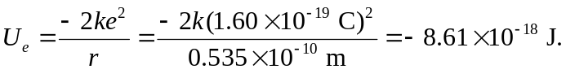
b) If all the kinetic energy goes into potential energy:

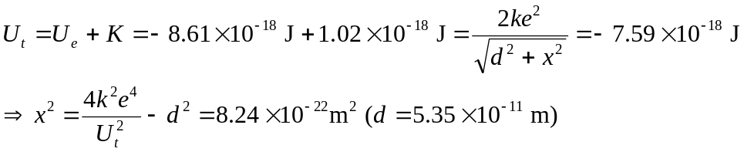
(Note that we must be careful to keep all digits along the way.) 